1. User’s Needs:

**Database Admin**

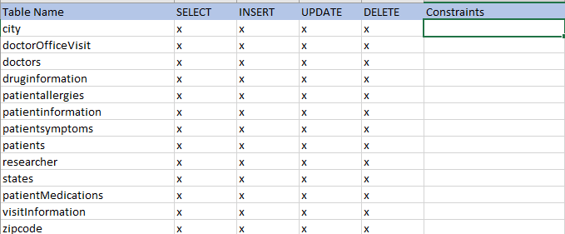

**Patient**

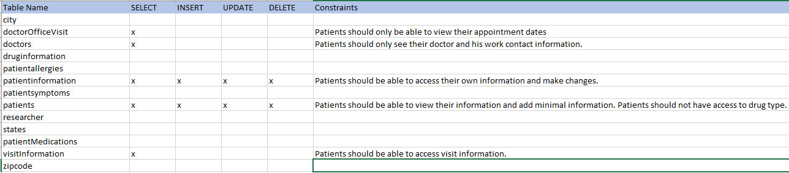

**Doctor**

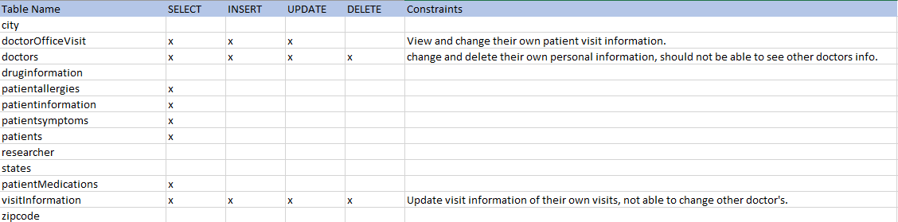

**Researcher**

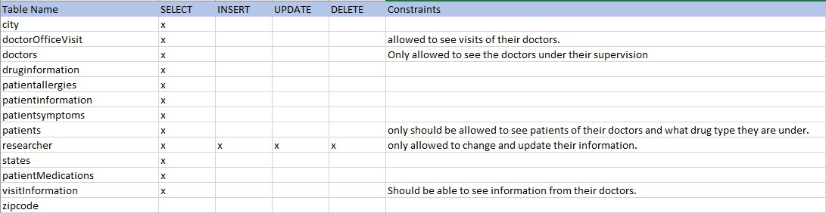

1. Security Plan

* Each user would have to authenticate by using a login associated with their patient ID number.
* Roles for Database Admin, researchers, and doctors.
* Creating views and procedures for each role to access the information that is required.

1. Documentation:

Patients should be allowed to log in under their account and view information, same as doctors and researchers. Other information pertains to above.

Database Admin

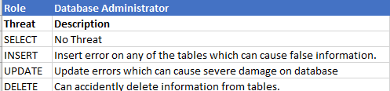

Database Admins have the power to accidently destroy information when fixing database issues.

Patient

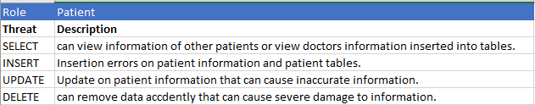

Doctors

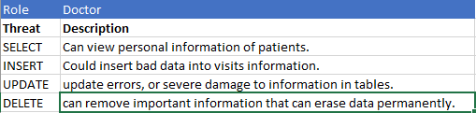

Doctors have the power to destroy information as they will be inserting their notes and other information into tables more than the Database Admins will.

Researcher

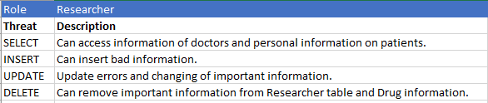

Researchers have access to view a lot of information but not the ability to change too much, still have a small chance of them messing with information.

1. Disaster Plan:

The hospital runs in a full-time environment and can’t afford to lose information at all when it comes to their patient’s information.

* Multiple backups should be performed daily in order to minimize the data loss.
* Database information should have multiple mirrors or replications so that if anything were to occur the database can fall back to other servers.
* Passwords, username, and recovery policies should be implemented to prevent hackings or to recover accounts that are locked.
* The database should be encrypted.
* Roles and other authorization methods implemented to make sure there is no users performing actions that they don’t have power to do.
* No public role for outsiders to hack into the database and retrieve confidential information.
* Follow state laws and other government regulations pertaining to patient health information and who has access to that information.

1. Create a View:

Researchers can view doctor visits from doctors, or doctors can view their own doctor visits by filtering out the specific doctor ID.

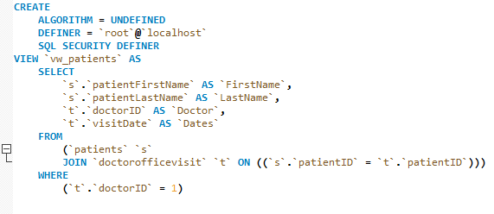

This shows what happens when the view executes:

